In our class demonstrations we went over the “Material Tab Controls” and the “Scoped Model” package available from pub.dev. These demonstrations are available on github, as part of “lab_3_begin”, (available at github.com/robbinl/flutter_2019fall_labs)

Your assignment is to take the project called “lab_3_begin” and add to it, the functionality described below. A screen shot of the running “lab_3_begin/lib/main.dart main() => MyAppLab3()”, is shown below. Notice, that there is no functionality (ex. back and forward arrows). If you tap anywhere, nothing happens. Just the UI layout is given to you.

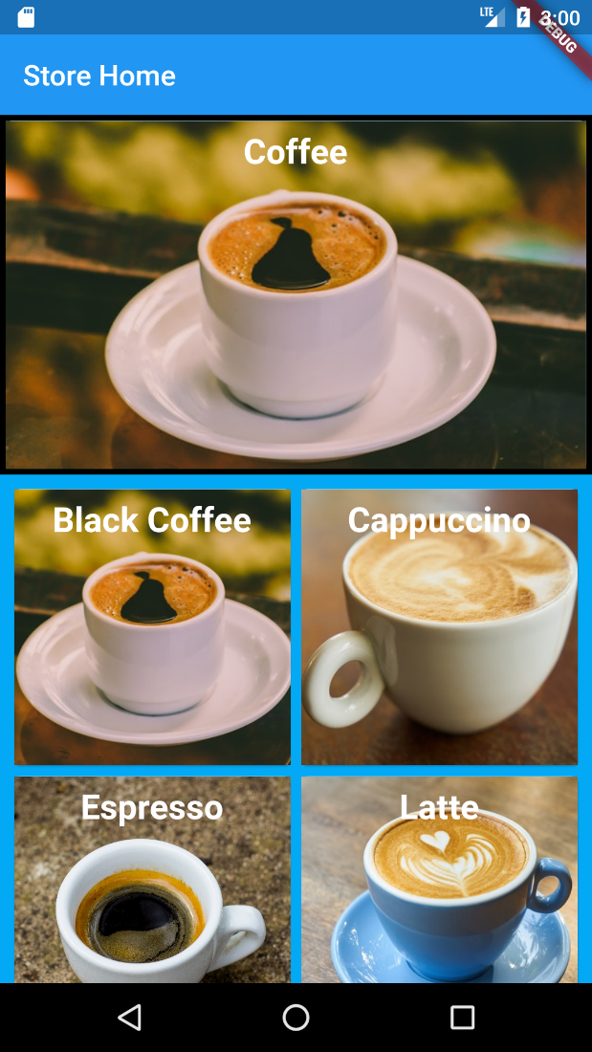

Part One of your assignment is to add to “lab_3_begin/lib/main.dart main() => MyAppLab3()”, a custom Tab Controller to add a carousel style of functionality to the “DrinksCarousel” widget, to switch between different kinds of drinks. Screen shots for the finished app are shown below. In order to get the arrows etc. on top of the image, read up and use a Stack widget.

Then you are to use the “Scoped Model” package to make the app function so that when the user taps on the carousel image for a particular type of drink, a “Material Gridview” of other drinks of that kind, show on the bottom of the screen. Read up on how to use “Material Gridview” at flutter.dev.

